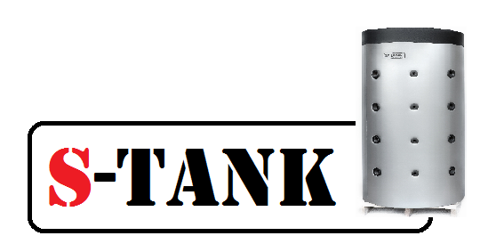

Data sheet for the HFWT series tank –300, 500, 750, 1,000, 1,200, 1,500, 2,000, 3,000 liters

For heating and domestic hot water systems

Republic of Belarus, township Ivenets, 2021

**HFWT series tank diagram**

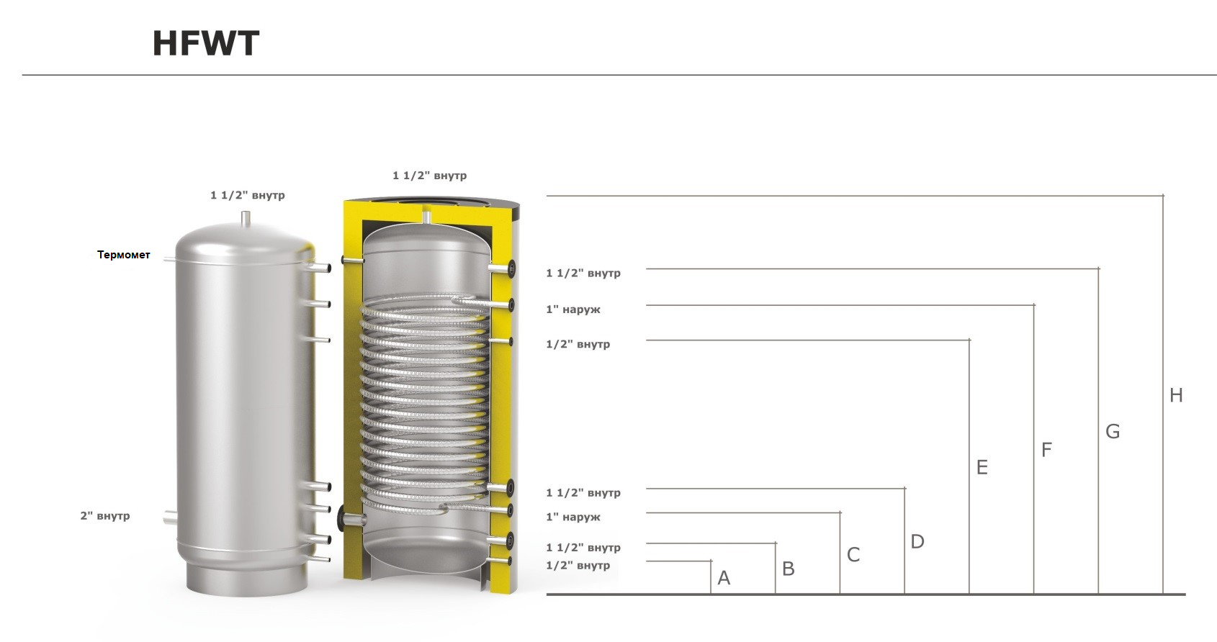

**Thermometer**

Outer

Outer

Inner

Inner

Inner

Inner

Inner

Inner

Inner

Inner

**Process functional diagram of the HFWT series tank**

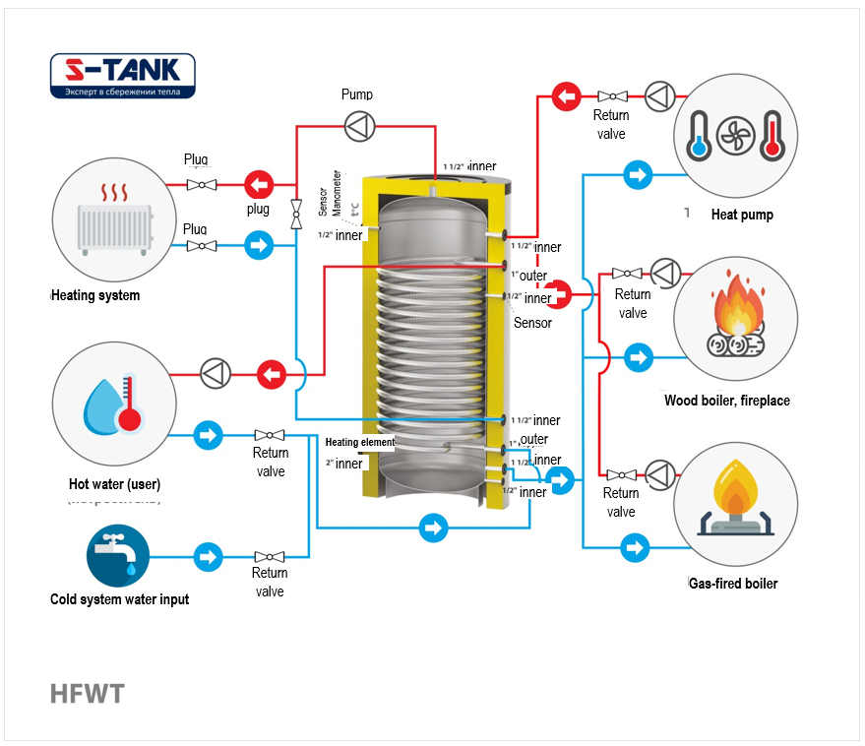

The HFWT series tank is a breakthrough in the domestic hot water systems. The tank of this series allows water in the DHW system to be heated by a continuous-flow method. Principle of operation: A high-performance heat exchanger is disposed in the tank which transfers heat of water heated in the tank to water flowing through the heat exchanger. Therefore, the water from your well having entered the heat exchanger is heated from 8 degrees to 60 degrees Celsius and higher, while passing through it. And at the outlet you get fresh hot water! This type of tanks is not exposed to Legionella infection! Very compact and easy to install. In addition, this design allows the DHW recirculation system to be easily created.

**Specifications**

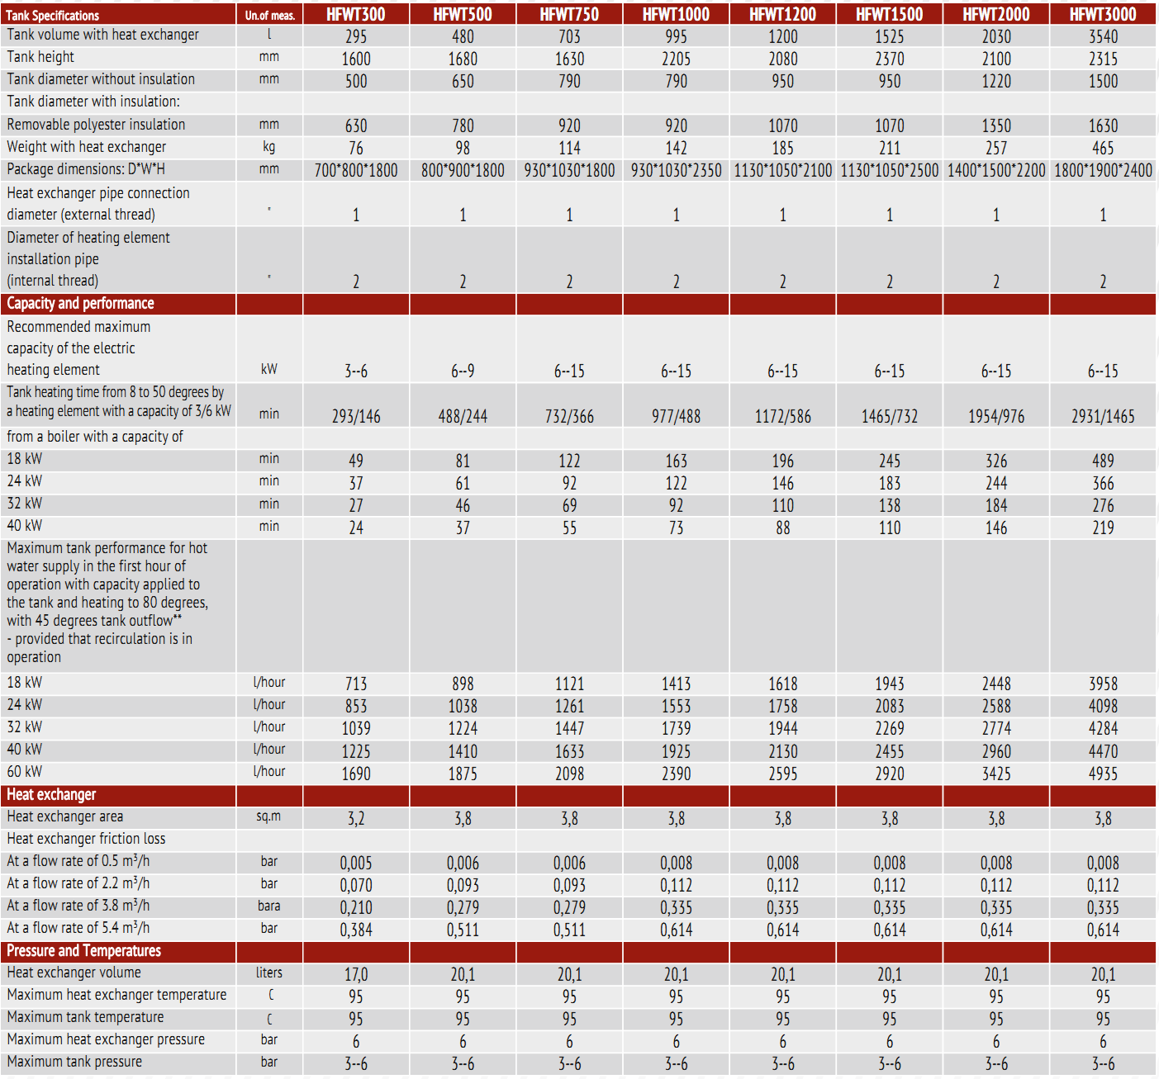

**Customized tanks with an operation pressure up to 10 bar can be manufactured.**

**Operation rules and recommendations.**

- When using the tank all-year-round, at the time of transition to the summer season during which not heating is required, you may use the tank for hot water supply from your boiler or heat pump by adjusting the system for maintaining the temperature in the tank at the level you require. In this case, you should cut off taps number 14 and 15 and open a tap number 13 on the bypass, thereby maintaining the circulation via a small loop (in this operating mode, a circulating pump of the heating system should remain operable if you wish to be fully supplied with DHW). If there is no need in such high DHW supply, the heating system circulating pump may be turned off. In this case, you will get a supply of 50-100 liters of hot water per one tap opening (with a two-minute interval opening). This is related to the fact that in the absence of circulation in the tank, at a maximum load for the DHW draw-off, the nearest water layers adjacent to the heat exchanger transfer their heat at extremely high rate, while the remaining tank volume still remains in a hot condition. Therefore, the circulation should be maintained in the tank to always get a full DHW supply.

- To safe electric power, we recommend to mount time relays on your circulating pumps or any other outside automatic circulation control devices. This allows you to save electric power at night when hot water is not used or when you are not at home for several hours or days.

The above tank installation diagram shows the DHW system without recirculation, however, if you need a system with recirculation, you may include a return pipeline and recirculating pump into the diagram.

**It is mandatory to mount a return valve to prevent overflow of hot water to cold water!!!**

If you need to install multiple DHW tanks to form a cascade system, you may mail a request for the installation diagram to our specialists at:

[alfa-vim@mail.ru](mailto:alfa-vim@mail.ru)

- We would like to pay your attention to the fact that it is not permitted to heat water to extremely high temperatures of +65 and higher as you may burn your skin while washing with overheated water. To control the DHW temperature, you may install an admixing assembly on the supply and return DHW draw-off lines and select the required DHW temperature (according to sanitary norms the DHW from 55 to 60 degrees, while water at a temperature of 39-45 degrees is considered comfortable for a user).

**Depending on the capacity of your DHW circuit, an expansion tank (10% of the circuit capacity) and a safety assembly (for 6 bar level) should be mounted on this circuit since the system is closed.**

**The DHW circuit heat exchanger is made of high-quality stainless steel (AISI304 and AISI 316 L grades).**

**With this system you will spared from replacing magnesium anodes every 0.5-1 year.**

1. Description

1.1 The **HFWT** series tank is designed for use in the heating systems offering the possibility of supplying DHW. In addition, the tank allows multivalent heating systems to be created by using the maximum number of heat sources.

2. The thermal energy storage tank is designed to operate at a temperature of water, water-glycol solutions as well as alcohol solutions ranging from +2 to +95 °C

1.3 All models in this series have the following design features:

A) The tanks are made of carbon steel, heat exchangers are made of AISI 304 stainless steel and are designed for durable operation.

B) The lower support for the tank is made in the form of a ring bearing allowing the tank weight to be uniformly distributed over the floor surface and maintaining stability.

C) All tanks are equipped with inlet and outlet fittings made from a seamless thick-walled tube.

On the outside, the standard design tanks with a capacity of up to including 1,000 l are protected by plastic covering. The tanks having the capacity over 1,000 l are protected by a plastic or fabric covering. Please contact a seller to obtain the information about the insulation color range.

Available option: tank modification according to a customer drawing (branch pipe mounting location, flanges, connection diameters, type and thickness of insulation) is calculated individually.

Arrangement, installation and operation.

2.1 Prior to the tank installation, please, read the Tank Data sheet and Installation and Operating Manual. (see at s-tank.ru)

2.2. Installation location needs to be chosen so that:

in case of leakage from the tank the water is drained to a sewer trap and then discharged from the premises without consequences;

it can be protected from shocks, industrial vibration, exposure to atmospheric precipitation (to be installed only in the premises). Any shock or mechanical impact may destroy the thermal insulation material and also cause tank leakage resulting in the tank failure!

When proceeding with the installation, it needs to be accounted that a free access should be provided to the tank for connecting, maintaining and disassembling it.

2.3 The tank should be installed by skilled specialists and persons having a certificate or a license for performing works related to the heating system installation! The installation needs to be confirmed in the Warranty Certificate.

**2.4. Wash the tank with water before putting it into operation!**

- The tank should be earthed; for this purpose, one or more plates are welded to its support part at the tank bottom for securing them to a tray, and in their turn they may be also used for connecting the earth to the tank. The earthing bus resistance should be not more than 4 Ohm. An access to the earthing bus is to be provided by the Customer.

- The magnesium anode (if available) should be replaced at least once every 6 months.

2.5. Acceptance of goods in terms of quality, completeness and quantity of units of goods in a package is to be made by the Buyer within two calendar days from receipt of the goods, but not later than 14 (fourteen) calendar days from the date of the goods handover.

2.6. It is not permitted to start operation of the tank without filling it with a technical fluid (water, antifreezing agent, etc.).

2.7. It is not permitted to operate the tank without a properly functioning safety valve. The safety valve condition needs to be inspected every 14 days by turning a head (handle) to the left or to the right so that the fluid could flow from a side outlet to the outside. Then, set the handle in the initial position. If no fluid flows when turning the handle, then the valve is out of order. When turning the handle and returning it to the initial position a continuous fluid leakage is observed, then a valve plunger is soiled. Wash the valve several times by opening the outlet by turning the handle. To avoid the uncontrolled water outflow, a hose need to be mounted to drain fluid to the sewer.

The company is not liable for the abnormal operation of the safety valve caused by incorrect mounting of the valve and errors in the system, for example, absence of a pressure-relief valve in the cold water supply system.

2.8. It is prohibited to block fluid dripping from the safety valve - do not plug a safety valve port. If the valve continuously leaks, this means that either the pressure in the system is too high or the safety valve is out of order. The drain valve outlet should be oriented downward. It is recommended to mount a funnel under the valve for fluid drainage. A drainage hose may be mounted and put into the sewer to remove fluid which flows when opening the safety valve. The hose should withstand a temperature of +95 degrees Celsius, has an inner diameter of 9 mm, maximum length of 1.2 m and a plane for water flow with an inclination downward (min 3%) and needs to be mounted in the premises in which the temperature does not drop below 0 degrees Celsius. The hose should be protected from mechanical damage and its outlet should be seen (to monitor the valve operation).

2.9. The tank should not be installed in close proximity o open fire or contact with the boiler insulation; when mounting a heating system with the tank, an installing organization should ensure compliance with fire safety regulations during the tank operation!

2.10. All works related to maintenance and installation should be performed in compliance with effective occupational safety rules.

3. Tank selection

3.1 The tank is to be selected individually depending on the heating system parameters or according to the project documentation.

3.2 The manufacturer reserves the right to make technical changes according to design documentation.

4. Warranty

4.1 The manufacturer guarantees conformity of the S-TANK thermal energy storage vessels, HFWT series, to safety requirements, provided that the user observes transportation, storage, installation and operation rules. The warranty period - 2 years from the date of sale by the manufacturer. The warranty period of the outer paint-and-lacquer coating is 6 months, provided that storage and transportation rules are observed.

4.2 Warranty implementation procedure. If warranty claims are grounded, the S-TANK WATER HEATERS service division takes a decision regarding the methods of eliminating identified faults - either by repairing or replacing a failed device. The warranty period specified in the Warranty Certificate remains unchanged in this case. In case of replacement of the failed device with a new one, the warranty period is not extended and the replacement is recorded in the Warranty Certificate.

4.3 The warranty does not cover the defects occurred due to the fault of the user as a result of violation of installation and operation rules and requirements of the Certificate and also in case of mechanical damage.

4.4. As regards malfunctions detected during the warranty period, please, contact the manufacturer/importer. A free-of-charge repair of malfunctions occurred to the fault of the manufacturer should be performed within the period specified in the effective legislation from the date of certifying the failure as a warrantable failure by the manufacturer/importer.

IMPORTANT - It is not permitted to dismantle the tank upon occurrence of the warranty case until you got the manufacturer's permission.

4.5. To submit the notification of defects to the service division of the Importer/Seller, the following needs to be specified: invoice number and factory number of the product (read the information label), date of procurement, malfunction description, correct installation site address and telephone contact number.

4.6. The condition for performing the tank warranty repair implies submission of the sales receipt, invoice and Warranty Certificate, correctly and fully completed, with the name of the seller and installing organization and without any corrections. The Warranty Certificate needs to be retained within the entire period of the equipment operation.

4.7. It is not permitted to operate the tank without a properly functioning safety valve. To comply with the warranty, the purchase of a respective safety valve and safety valve Warranty Certificate need to be confirmed.

4.8. Installation and commissioning of the tank, being the warranty item, should be performed by skilled specialists subject to the rules established by the legislation and also according to Installation and Operating Manual. ( see at s-tank.ru)

4.9. Protect to tank from direct solar radiation exposure.

4.10. The tank should be installed in zones not subjected to weather effects (rain, snow, etc.)

4.11. Plastic pipes not designed to operate at a temperature of 100 degrees Celsius and at a pressure 1.0 MPa should not be used for the tank connection.

4.12. The tank should be installed so that a free access is provided to it for maintenance.

4.13. The manufacturer is not liable for possible inconveniences or expenses related to the structural changes of a building/premises needed to meet the conditions of the tank installation location (for example, narrow doors or corridors) - the request for compensation the expenses will be declined by the manufacturer. If there is a need to install a water heater in a specific place (for example, in the attic or in a room with a floor sensitive to water impact, warehouses, etc.), the room should be protected against possible water ingress and the issue of mounting devices for collecting and draining this water to avoid damage should be considered.

4.14. All mechanical defects of the tank lead to the loss of warranty.

4.15. The following will not be considered by the warranty if:

- the heating system with the tank was filled not with the distilled water solution or specially prepared solution for filling the heating system, with the respective quality certificate being provided (for tanks configured for heating systems);

- the heating system was not earthed (this is necessary to prevent the influence of parasite (earth) currents on metal and as a result, corrosion occurrence and acceleration);

- the tank was used in heating systems with air available in the network (for tanks configured for heating systems);

- the tank was used in the heating system not equipped with a respective safety assembly for excessive pressure release;

- the tank was used in aggressive media;

- the installation does not meet the quality requirements;

- the expansion tank of a required capacity (10% of the system capacity) is not available for the closed system;

- damage was caused by improper transportation;

- damage was caused intentionally or damage occurred due to negligence;

- mechanical damage or damage are caused by weather effects (for example, frost) or actions arising from exceeding the allowable operational pressure specified in the Data sheet

- accidents are caused by installation or operation of malfunctioning or damaged safety valves

- damage resulted from improper use;

- damage resulted from non-observance of rules contained in the Data sheet or in the Tank Installation and Operating Manual (see at www.s-tank.ru);

- damage occurred as a result of fire, flood, lightning strike, voltage surge in the electrical network or other cases;

- accidents occurred as a result of using non-original spare parts such as TEH assembly, magnesium anode, titanium anode, thermostat, thermometer, gaskets, etc.;

- electrochemical corrosion occurred;

- damage was caused by non-replacement of the magnesium anode within the period specified in the Data sheet (if it is available in the tank design).

4.16. The tank repair techniques are to be defined by the manufacturer.

4.17. A free-of-charge repair does not include as follows: tank adjustment, magnesium anode replacement, seal replacement or other parts naturally wearable in the process of operation.

4.18. These are the only warranty conditions of the manufacturer. No other warranties are accepted, unless manufacturer's instructions in writing are provided.

4.19. Civil Code regulations are applied to the issues not addressed by these conditions.

- The quality of sanitary hot water in the heat exchanger should comply with the following standards:

|  |  |  |
| --- | --- | --- |
| **Conductivity mc/cm *)** | **>450** | **-** |
| **pH** | **<6** | **0** |
|  | **6-8+** | **+** |
|  | **>8** | **-** |
| **Chlorides (mg/l)** | **>50** | **-** |
| **Sulfur compounds(mg/l)** | **<50+** | **+** |
|  | **50-200 0** | **0** |
|  | **>200** | **-** |
| **Nitrogen compounds (mg/l)** | **<100** | **+** |
| **Carbon dioxide (mg/l)** | **<5 +** | **+** |
|  | **5-20 0** | **0** |
|  | **>20** | **-** |
| **Oxygen (mg/l)** | **<1 +** | **+** |
|  | **1-8 0** | **0** |
|  | **>8** | **-** |
| **Amone (mg/l)** | **<2 +** | **+** |
|  | **2-20 0** | **0** |
|  | **>20** | **-** |
| **Ferrum and manganese (mg/l)** | **>0.2** | **0** |
| **Sulfur compounds(mg/l)** | **<5** | **-** |
| **Chlorine (mg/l)** | **<0.5** | **+** |

*) at 20 degrees Celsius

+ = resistant material

0 = destruction may occur, if several substances reach the value of ‘’ 0 ‘’

- = not recommended to use

5. Storage conditions:

Store the product prior to commissioning in a heated room at a temperature not below 20°С and relative humidity not more than 65%.

**Standard product configuration:**

1. Tank - 1 ps
2. Thermal insulation - 1 ps
3. Upper decorative cover with a seal (plastic up to 1,000 l, fabric - 1,200 l and more) - 1 pc
4. Thermometer - 1 ps
5. Product Certificate - 1 ps

Technical Control Department

Quality control for defects was performed by Gubsky M.N., specialist of the Technical Control Department (TCD)

Sale date ________________________________________________________

Signature of Seller ________________________________________________________

Name and address of the trading organization __________________________________________________________________________________________________________________________________________________

Seal

Name and address of the mounting organization ___________________________________________________________________________________________________________________________________________________________________

Seal

Manufacturer:

S-TANK WATER HEATERS LTD, RB, Minsk Region

Build. 72B, 17-ogo Sentyabrya Str., township Ivenets, Volozhinsky District

Tel-fax 8(01772) 6 77 11; Tel. +375296325040, +375296131414

Technical support: [alfa-vim@mail.ru](mailto:alfa-vim@mail.ru)