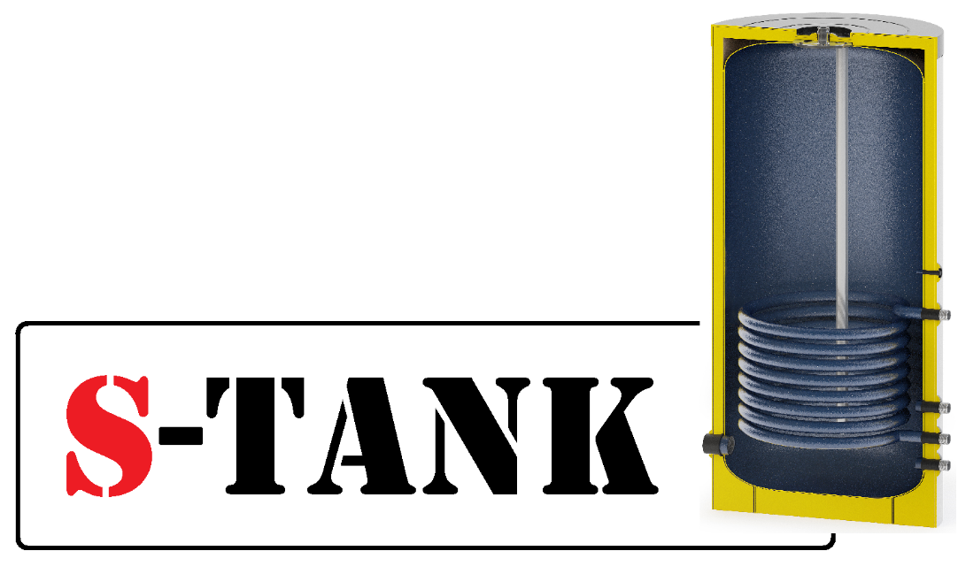
Data sheet for the Tank of
"P" Series
150
200
300
400
500
750
1,000
liters
for the DHW systems

"P" series tank diagram
An inspection fitting flange with 1" external thread (for tanks up to and including 500-liter capacity) Tank window inner diameter 84 mm A flange cover is secured with six М8 bolts, strength grade - 8 8 A magnesium anode is threadedly secured (M8 thread) on the inner surface of the flange cover
An inspection fitting flange with 1 1/4” external thread (for tanks 750 and 1,000-liter capacity) Tank window inner diameter 150 mm A flange cover is secured with 8 М12 bolts, strength grade - 8 8 A magnesium anode is threadedly secured (M8 thread) on the inner surface of the flange cover
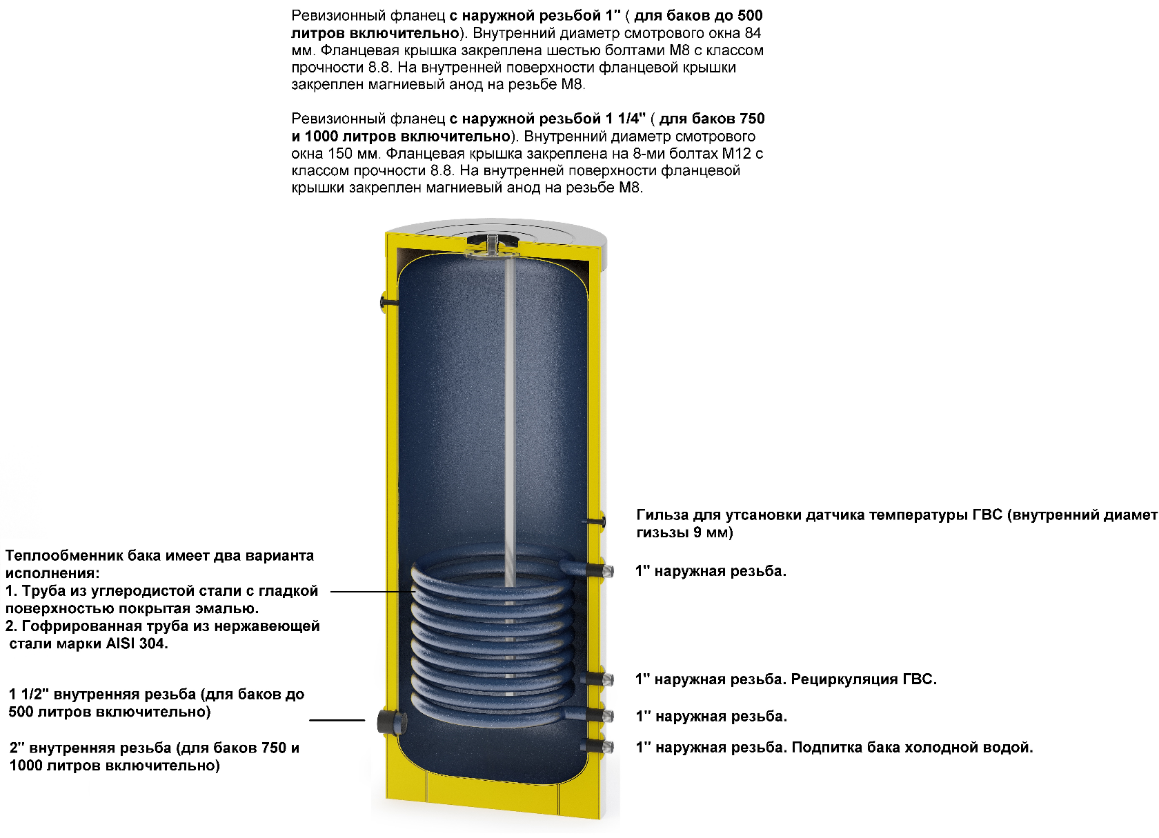
1" external thread. Tank cold water makeup.
1" external thread.
1" external thread. DHW recirculation.
1" external thread.
Sleeve for mounting DHW temperature sensor (sleeve inner diameter - 9 mm)
The tank heat exchanger is provided in two design versions:
1.Carbon steel tube with smooth enamel-coated surface.
2.AISI 304 stainless steel corrugated tube.
1 1/2" internal thread (for tanks up to and including 500- liter capacity)
2" internal thread (for tanks 750 and 1,000-liter capacity inclusively)
Field of application: - Accumulation and storage of heated sanitarywater.
Product material: - Carbon steel with enamel coating.
Description: - The tank is designed to accumulate hot water from various heat sources. The 'P' series tank improves the hot water supply system flexibility, allowing you to accumulate a constant volume of hot water and use hot water supply recirculation to increase comfort of use. In this case, the possibility of connecting an electric heater via a 2" (for 750 and 1,000 litre tanks) or 1 1/2" (for up to and including 500 litre tanks) internal thread bore at the tank bottom makes the tank more versatile. The tank can operate in combination with the following heat sources:
Solid fuel-fire boiler Biomass boiler Pellet boiler Fireplace with a water jacket
Gas-fired boiler Electric boiler Solar collector

Tank insulation
Two types of insulation are available for this tank
Removable rigid polyurethane foam insulation with an average thickness of 37 mm (thermal conductivity coefficient - 0.028 W/m*K) – for tanks up to and including 500 liters.
Also a removable soft polyester insulation with an average thickness of 65-70 mm made using NOFIRE technology with B-s2d0 fire-resistance class in accordance with the European standard EN 13501 requirements (thermal conductivity coefficient of the material - 0.031 W/m*K) is available
Options available:
- Changes in the tank design by the Customer drawing (location of connection branch pipes, flanges,
connection diameters, insulation type and thickness, heat exchanger surface area and so forth) - are to be calculated inividually.
Process functional diagram of the "P" series tank
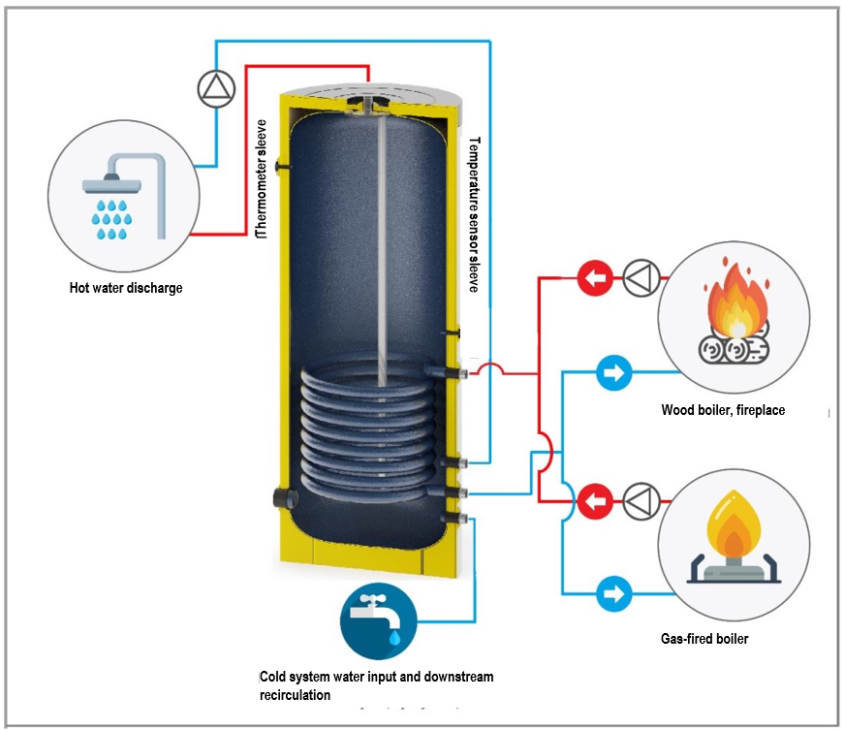
A diagram with an anti-burn valve and tank recirculation 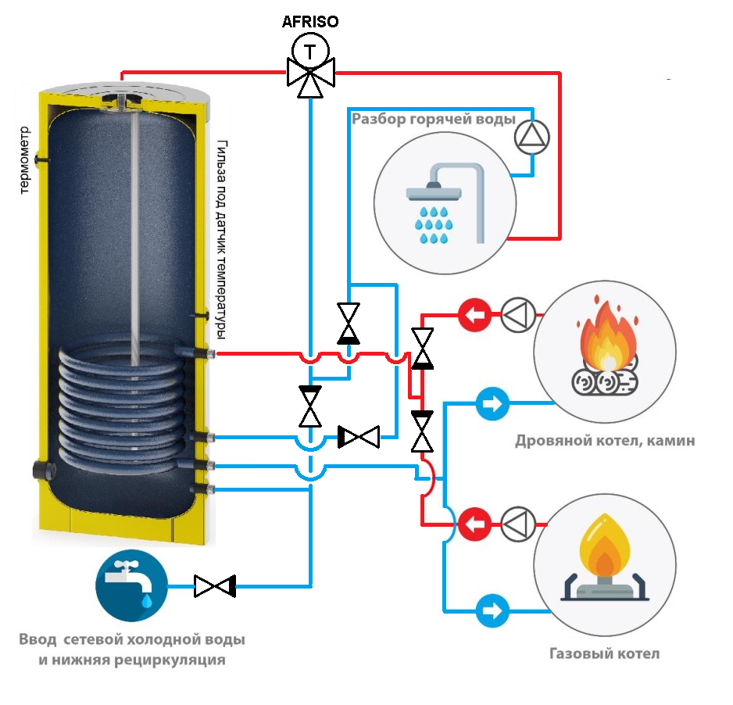
Hot water supply discharge
Wood boiler, fireplace
Gas-fired boiler
Cold system water input and downstream recirculation
Thermometer
Temperature sensor sleeve
Specifications
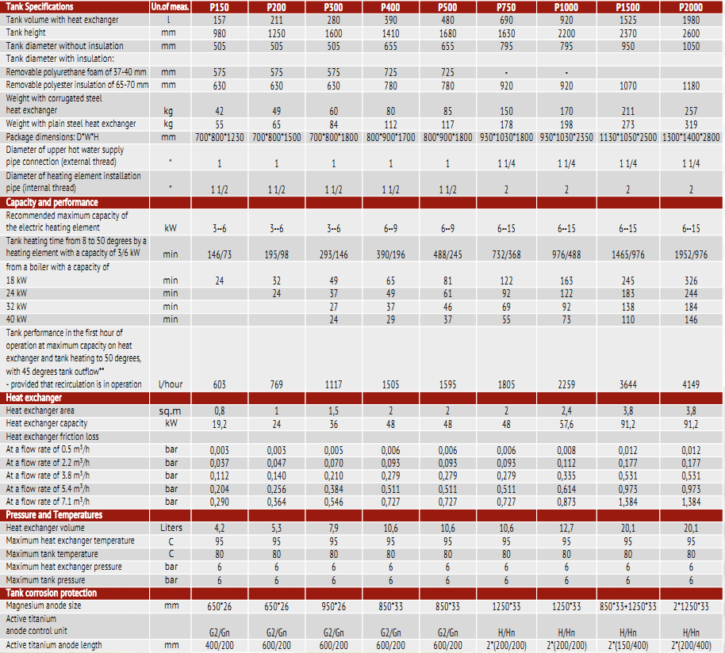

- Description
1.The P series tank is designed for use in DOMESTIC HOT WATER systems!
2. The P series tank is designed for operating water temperatures ranging from +2 to +80 degrees Celsius.
1.3 All models in this series have the following design features:
A) The lower support for the tank is made in the form of a ring bearing allowing the tank weight to be uniformly distributed over the floor surface and maintaining stability.
B) All tanks are equipped with inlet and outlet fittings made from a thick-walled tube.
On the outside, the standard design tanks with a capacity of up to including 1,000 l are protected by plastic covering.

- Arrangement, installation and operation.

2.1 Prior to the tank installation, please, read the Tank Data sheet and Installation and Operating Manual (read on www.s-tank.ru)

2.2 Installation location needs to be chosen so that:
- in case of leakage from the tank the water is drained to a sewer trap and then freely discharged from the premises;
- it can be protected from shocks, industrial vibration, exposure to atmospheric precipitation (to be installed only in the premises). Any shock or mechanical impact may destroy the thermal insulation material and also produce failures in the integrity of the tank internal coating, cause tank leakage resulting in the tank failure!
When proceeding with the installation, it needs to be accounted that a free access should be provided to the tank for connecting, maintaining and disassembling it.
2.3 The tank should be installed by skilled specialists and persons having a certificate or a licence for performing works related to the heating system installation! The installation needs to be confirmed in the Warranty Certificate.
2.4. Wash the tank with water before putting it into operation!
2.4.1 The tank should be earthed; for this purpose, one or more plates are welded to its support part at the tank bottom (or at the tank top, for the flange bolt) for securing them to a tray, and in their turn they may be also used for connecting the earth to the tank. The earthing bus resistance should be not more than 4 Ohm. An access to the earthing bus is to be provided by the Customer.
2.5. Acceptance of goods in terms of quality, completeness and quantity of units of goods in a package is to be made by the Buyer within two calendar days from receipt of the goods, but not later than 14 (fourteen) calendar days from the date of the goods handover.
2.6. The magnesium anode replacement period is not later than 6 months from the start of operation. The magnesium anode should be visually inspected at least once every 3 months (if the anode diameter reduced by more than 10 mm at least in one place, it should be immedially replaced). The titanium anode functionality should be tested at least once a year by a maintenance engineer with the test results being entered into the Certificate (no replacement is required in case of normal operation). The anode test results and replacement should be recordered in the Certificate (test date, test results). When installing the tank, one should take into consideration the fact that the anode is mounted on the inside of an upper tank flange cover, therefore, the structure should be made demountable so that in the future the anode replacement procedure can be fast and easy!!!
2.7. It is not permitted to put the tank in operation without filling it with water.
2.8. It is not permitted to operate the tank without a properly functioning safety valve. The safety valve condition needs to be inspected every 90 days by turning a head (handle) to the left or to the right so that the fluid could flow from a side outlet to the outside. Then, set the handle in the initial position. If no fluid flows when turning the handle, then the valve is out of order. When turning the handle and returning it to the initial position a continuous water leakage is observed, then a valve plunger is soiled. Wash the valve several times by opening the outlet by turning the handle. To avoid the uncontrolled water outflow, a hose need to be mounted to drain water to the sewer. Important - hot water may flow out. Excessive amount of water leaks from the safety valve as a result of the following:
1) inlet water pressure is higher than allowable;
2) short-term pressure surges of inlet water are not considered to be a warranty case and the valve is not subject to replacement. The company is not liable for the abnormal operation of the safety valve caused by incorrect mounting of the valve and errors in the system, for example, absence of a pressure-relief valve in the cold water supply system.
2.9. It is prohibited to block fluid dripping from the safety valve - do not plug a safety valve port. If the valve continuously leaks, this means that either the pressure in the water supply system is too high or the safety valve is out of order. The drain valve outlet should be oriented downward. It is recommended to mount a funnel under the valve for water drainage. A drainage hose may be mounted and put into the sewer to remove water which flows out when opening the safety valve. The hose should withstand a temperature of +95 degrees Celsius, has an inner diameter of not less than 9 mm, maximum length of 1.2 m and a plane for water flow with an inclination downward (min 3%) and needs to be mounted in the premises in which the temperature does not drop below 0 degrees Celsius. The hose should be protected from mechanical damage and its outlet should be seen (to monitor the valve operation).
2.10. The tank should not be installed in close proximity o open fire or contact with the boiler insulation; when mounting a heating system with the tank, an installing organization should ensure compliance with fire safety regulations during the tank operation!
2.11. The tank should be immediately disconnected if steam escapes from a mixer (this case should be reported to the Service Center)
2.12. Continuous tank operation at a maximum temperature causes wear of the tank electrical part.
2.13. A proper protection of a boiler operating in combination with the tank guarantees protection of the tank heat exchanger.
2.14. Preventive washing should be conducted every 12 months to wash out sediment from the tank.
2.15. To prolong the tank service life and ensure trouble-free operation of the safety valve, filters need to be used to prevent clogging.
2.16. A water heater should be connected directly to the water supply system having a pressure not more than 0.6 MPa (about 6 bar), while the minimum pressure should not be less than 0.1 MPa (1 bar). The cold water supply pipe should be fitted with a safety valve. The safety valve outflow port should be permanently opened and connected to the atmosphere. It is not permitted to mount any device (for example, a return valve, a shut-off valve) between a relief valve and the water heater, however, a T-shaped pipe with a drain valve may be mounted. When the pressure in the water supply system exceeds 0.6 MPa, it needs to be reduced using a pressure-relief valve.
2.17. All works related to maintenance and installation should be performed in compliance with effective occupational safety rules.

2.18. CAUSES OF MALFUNCTIONS
Malfucntions | Cause | Troubleshooting
Relief valve does not open (also when purged) | - Relief valve is clogged | - Clean the valve or replace it
- Relief valve leaks | - Relief safety valve is clogged or damaged  - Water pressure is too high | - Clean safety valve  - Use pressure reducing valve
- Water in water heater became dirty | - Too much sediment in the tank  - Magnesium anode is worn out | - Clean the tank from sediment  - Replace magnesium anode (not warranty case)

Depending on the capacity of your DHW circuit, an expansion tank (10% of the circuit capacity) and a safety assembly (for 6 bar level) should be mounted on this circuit since the system is closed.

3. Tank selection
3.1 The tank is to be selected individually depending on the heating system or DHW parameters or according to the project documentation. Prior to selecting a water heater, you should test the network cold water quality in your house to detect if it contains chemical substances specified in the Table provided below in the Data sheet. If the chemical composition is not in compliance with the required quality, a water conditioning and purification equipment needs to be installed prior to the tank installation. Before installation make sure that earthing bus resistance in your house is not higher than 4 Ohm - this will make the life of your relatives and people much more safe and will protect your tank from the adverse effect of earth currents.
3.2 The manufacturer reserves the right to make technical changes according to design documentation.

4. Warranty
4.1 The manufacturer guarantees conformity of the S-TANK tanks, "P" series, to safety requirements, provided that the user observes transportation, storage, installation and operation rules The warranty period - 5 years from the date of sale by the manufacturer of the tank with the magnesium anode and 10 years with the active titanium anode (one-time purchase and installation of the titanium anode and tank). These warranty obligations will enter into effect upon registration of the product with the manufacturer within two months from the date of purchase.
The product is to be registered by mailing the required information to the manufacturer's address
s-tank.garan@mail.ru, the list of required documents is provided in the Installation and Operating Manualhttp://s-tank.by/wp-content/uploads/Instrukcziya-po-montazhu-i-ekspluataczii-bakov-S-TANK-2.pdfin case the product is not registered, the warranty period is 1 (one) year from the date of sale.
4.2 Warranty implementation procedure. If warranty claims are grounded, the S-TANK WATER HEATERS service division takes a decision regarding the methods of eliminating identified faults - either by repairing or replacing a failed device. The warranty period specified in the Warranty Certificate remains unchanged in this case. In case of replacement of the failed device with a new one, the warranty period is not extended and the replacement is recorded in the Warranty Certificate.
4.3 The warranty does not cover the defects occurred due to the fault of the user as a result of violation of the Installation and Operating Manual, requirements of the Certificate and also in case of mechanical damage.
4.4. As regards malfunctions detected during the warranty period, please, contact the manufacturer/importer. A free-of-charge repair of malfunctions occured to the fault of the manufacturer should be performed within the period specified in the effective legislation from the date of certifying the failure as a warrantable failure by the manufacturer/importer.
IMPORTANT - It is not permitted to dismantle the tank upon occurrence of the warranty case until you get the manufacturer's or importer's permission.
4.5. To submit the notification of defects to the service division of the Importer/Seller, the following needs to be specified: order number and factory number of the product (see the information label), date of procurement (sales receipt, invoice) malfunction description, correct installation site address and telephone contact number of a person operating the tank.
4.6. The condition for performing the tank warranty repair implies submission of the sales receipt, invoice and correctly and fully completed Warranty Certificate by the user, with the name of the seller and installing organization and without any corrections. The Warranty Certificate needs to be retained within the entire period of the equipment operation.
4.7. It is not permitted to operate the tank without a properly functioning safety valve. To comply with the warranty, the purchase of a respective safety valve and safety valve Warranty Certificate need to be confirmed.
4.8. Installation and commissioning of the tank, being the warranty item, should be perfomed by skilled specialists subject to the rules established by the legislation and also according to Installation and Operating Manual (read on www.s-tank.ru )
4.9. Protect to tank from direct solar radiation exposure.
4.10. The tank should be installed in zones not subjected to weather effects (rain, snow, etc.)
4.11. Plastic pipes not designed to operate at a temperature of 100 degrees Celsius and at a pressure 1.0 MPa should not be used for the tank connection.
4.12. The tank should be installed so that a free access is provided to it for maintenance.
4.13. The manufacturer is not liable for possible inconveniences or expenses related to the structural changes of a building/premises necessary for moving in or moving out, installing or dismantling the tank (for example, narrow doors or corridors) - the request for compensation the expenses will be declined by the manufacturer. If there is a need to install a water heater in a specific place (for example, in the attic or in a room with a floor sensitive to water impact, warehouses, etc.), the room should be protected against possible water ingress and the issue of mounting devices for collecting and draining this water to avoid damage shoud be considered.
4.14. All mechanical defects of teh tank lead to the loss of warranty.
4.15. The relief valve should be mounted directly upstream the tank on a tube supplying cold water to it. Use only the valves complying with specifications and designed for storage water heaters. The safety valve should be used in accordance with the Valve Operating Instruction.
4.16. It is strictly prohibited to mount additional devices (for example, a shut-off valve, return valve, etc.) between the safety valve and the water heater. It is only recommended to mount a T-shaped pipe for draining wate from the tank.
4.17. It is prohibited to install the tank in the premises in which the ambient temperature may drop below 0 degrees Celsius.
4.18. The following will not be considered by the warranty if:
- the heating system with the tank was filled not with the specially conditioned water or specially prepared solution for filling the heating system, with the respective quality certificate being provided (for tanks configured for heating systems); Either purified or treated water shoud flow through the DHW tank heat exchanger
- the heating system and tank were not earthed (this is necessary to prevent the influence of parasite (earth) currents on metal and as a result, corrosion occurrence and acceleration);
- the tank was used in heating systems with air available in the network (for tanks configured for heating systems);
- the tank was used in the heating and DHW system not equipped with a respective safety assembly for excessive pressure release;
- the tank was used in aggressive media;
- low-quality installation;
- the expansion tank of a required capacity (10% of the system capacity) is not available for the closed heating and DHW system;
- The quality of sanitary hot water in the tank should comply with the following standards:
Conductivity mc/cm *) | >450 | -
pH | <6 | 0
 | 6-8+ | +
 | >8 | -
Chlorides (mg/l) | >50 | -
Sulfur compounds(mg/l) | <50+ | +
 | 50-200 0 | 0
 | >200 | -
Nitrogen compounds (mg/l) | <100 | +
Carbon dioxide (mg/l) | <5 + | +
 | 5-20 0 | 0
 | >20 | -
Oxygen (mg/l) | <1 + | +
 | 1-8 0 | 0
 | >8 | -
Amone (mg/l) | <2 + | +
 | 2-20 0 | 0
 | >20 | -
Ferrum and manganese (mg/l) | >0.2 | 0
Sulfur compounds(mg/l) | <5 | -
Chlorine (mg/l) | <0.5 | +
*) at 20 degrees Celsius
+ = resistant material
0 - destruction may occur, if several substances reach the value of ‘’ 0 ‘’
- - not recommended to use
- damage was caused by improper transportation;
- damage was caused intentionally or damage occurred due to negligence;
- mechanical damage or damage are caused by weather effects (for example, frost) or actions arising from exceeding the allowable operational pressure specified in the Data sheet
- malfunctions caused by the use of fittings being not in compliance with effective standards;
- accidents caused by installation or operation of malfunctioning or damaged safety valves;
- damage resulted from improper use;
- damage occurred due to non-observance of the rules contained in the Tank Installation and Operating Manual and Data sheet;
- damage occurred as a result of fire, flood, lightning strike, voltage surge in the electrical network or other cases;
- accidents occurred as a result of using non-original spare parts such as TEH assembly, magnesium anode, titanium anode, thermostat, thermometer, gaskets, etc.;
- electrochemical corrosion occurred;
- damage caused by non-replacement of the magnesium anode or non-observance of regular inspection of the serviceability of the titanium anode within the terms specified in Data sheet;
- the cases in which the temperature of cold water running from the tap differs from the thermometer reading by about 12 degrees Celsius (this difference is likely to be caused, in particular, by the thermostate hysteresis, distance between the tank and a consum ption point, low temperature in a room in which the water heater is installed);
- cases related to the natural formation of scaling;
- damage resulting from irregular cleaning of the tank from scale and sediment;
4.19. The tank repair techniques are to be defined by the manufacturer.
4.20. A free-of-charge repair does not include as follows: tank adjustment, magnesium anode replacement, seal replacement or other parts naturally wearable in the process of operation.
4.21. These are the only warranty conditions of the manufacturer. No other warranties are accepted, unless manufacturer's instructions in writing are provided.
4.22. Civil Code regulations are applied to the issues not adressed by these conditions.
5. Storage conditions:
Store the product prior to commissioning in a heated room at a temperature not below 20°С and relative humidity not more than 65%.
Standard product configuration:
- Tank - 1 ps
- Unremovable thermal insulation up to 500 l, removable - 750 l and more - 1 pc
- Upper decorative cover with a seal (plastic up to 1,000 l, fabric - 1,200 l and more) - 1 pc
- Thermometer - 1 ps
- Product Certificate - 1 ps
- Magnesium anode - 1 ps
- Titanium anode with a power supply unit (option upon request) - 1 ps, in case the titanium anode is mounted, no need to mount the magnesium anode.

The manufacturer informs you that damage of the primer coating may occur on the outer metal surface of the tank due to the fact that the product was thermally treated at a temperature over 850 °C during the manufacturing process. This causes formation of oxides (ferrum oxide and others) on the tank outer surface which later may peel off from the surface together with the primer coating. This will not affect the tank serviceability and reduce the warranty period and service life of the product.

Sale date ________________________________________________________
Signature of Seller ________________________________________________________
Name and address of the trading organization _________________________________________________________________________________________________________________________________________________
Seal
Name and address of the mounting organization _________________________________________________________________________________________________________________________________________________Seal

Magnesium anode replacement Table
Replacement date | No. and date of sale receipt, invoice | Anode model | Organization replacing the anode | Full name | Signature

Table of titanium anode inspection
Inspection date | No. and date of sale receipt, invoice | Anode model | Organization performing the inspection | Full name | Signature
Manufacturer:
S-TANK WATER HEATERS LTD, RB, Minsk Region
Build. 72B, 17-ogo Sentyabrya Str., township Ivenets, Volozhinsky District
Tel-fax 8(01772) 6 77 11; Tel. +375296325040,
Technical support: alfa-vim@mail.ru

