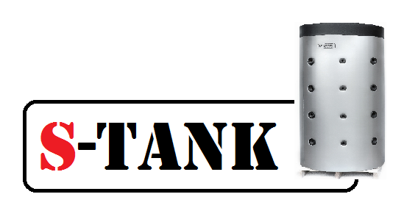

Data sheet for the Tank of

SOLAR SS DUO series – 200, 300, 500, 750, 1000, 1200, 1500, 2000 liters

for the DHW systems

Republic of Belarus, township Ivenets, 2021

**Description of SOLAR SS DUO series tank**

Field of application: - Accumulation and storage of heated sanitary water.

Product material: - AISI 304 stainless steel.

Description: - The tank is designed to accumulate hot water from various sources. The S-TANK SOLAR SS DUO series tank improves the DHW system flexibility, allowing you to accumulate a constant volume of hot water. Moreover, the possibility of connecting an electric heater via a 1 1/2" bore with internal thread for up to and including 500 litre tanks, and via 2" thread in the bottom of the tank for tanks over 500 litres, makes the tank more versatile. It efficiently combines the following heat sources:

* Solid fuel-fired boiler
* Biomass boiler
* Pellet boiler
* Fireplace with a water jacket
* Gas-fired boiler
* Electric boiler
* Solar collector

The tank insulation is made from 70 mm thick, 100% recyclable polyester (an environmentally friendly material) using the NOFIRE technology, this material is characterized by a high R-value and also a high B-s2d0 fire-resistance class in accordance with the European Standard EN 13501 requirements.

Options available:

- Tank design modification according to a customer drawing (connection branch pipe mounting location, flanges, connection diameters, type and thickness of insulation) is calculated individually.

.

**Process functional diagram of the SOLAR SS DUO series tank**

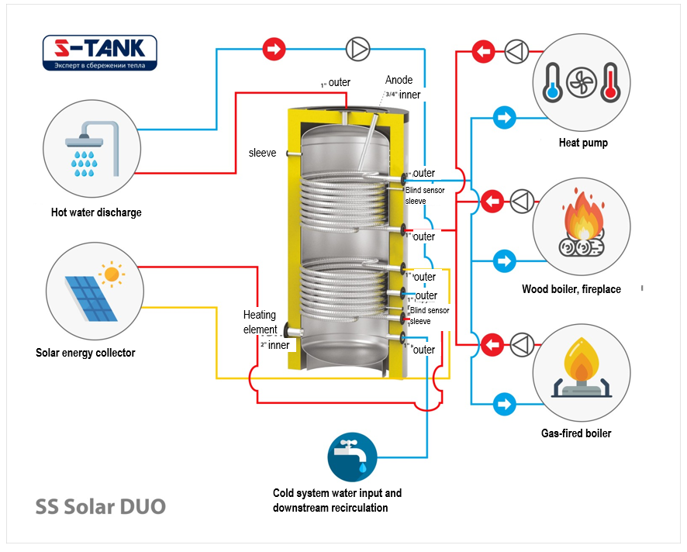

Description

1.1. 1.The SOLAR SS DUO series tank is designed for use in DOMESTIC HOT WATER systems!

1.2 The DHW tank is designed for operating water temperatures ranging from +2 to +80 degrees Celsius.

1.3 All models in this series have the following design features:

A) The tanks are made of AISI 304 high quality hard stainless steel and are designed for durable operation.

B) The lower support for the tank is made in the form of a ring bearing allowing the tank weight to be uniformly distributed over the floor surface and maintaining stability.

C) All tanks are equipped with inlet and outlet fittings made from a thick-walled tube.

On the outside, the standard design tanks with a capacity of up to including 1,000 l are protected by plastic covering. The tanks having the capacity over 1,000 l are protected by a plastic or fabric covering. Please contact a seller to obtain the information about the insulation color range.

**Specifications**

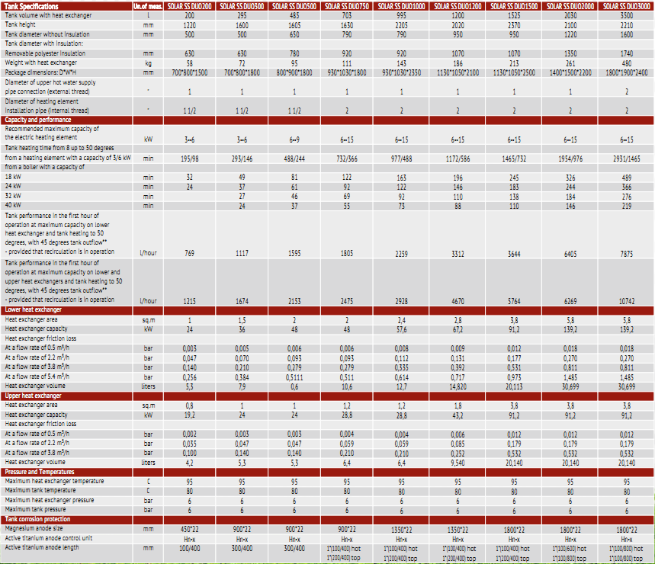

2. Arrangement, installation and operation.

2.1 Prior to the tank installation, please, read the Tank Data sheet and Installation and Operating Manual (read on [www.s-tank.ru](http://www.s-tank.ru))

2.2 Installation location needs to be chosen so that:

- in case of leakage from the tank the water is drained to a sewer trap and then freely discharged from the premises;

- it can be protected from shocks, industrial vibration, exposure to atmospheric precipitation (to be installed only in the premises). Any shock or mechanical impact may destroy the thermal insulation material and also cause tank leakage resulting in the tank failure!

When proceeding with the installation, it needs to be accounted that a free access should be provided to the tank for connecting, maintaining and disassembling it.

2.3 The tank should be installed by skilled specialists and persons having a certificate or a licence for performing works related to the heating system installation! The installation needs to be confirmed in the Warranty Certificate.

**2.4. Wash the tank with water before putting it into operation!**

- The tank should be earthed; for this purpose, one or more plates are welded to its support part at the tank bottom for securing them to a tray, and in their turn they may be also used for connecting the earth to the tank. The earthing bus resistance should be not more than 4 Ohm. An access to the earthing bus is to be provided by the Customer.

2.5. Acceptance of goods in terms of quality, completeness and quantity of units of goods in a package is to be made by the Buyer within two calendar days from receipt of the goods, but not later than 14 (fourteen) calendar days from the date of the goods handover.

2.6. The magnesium anode replacement period is not later than 6 months from the start of operation. The magnesium anode examination should be performed at least once every 6 months. The Correx anode functionality test should be performed at least once a year. Anode test results and replacement should be recordered in the Certificate (test date and test results).

2.7. It is not permitted to put the tank in operation without filling it with water.

2.8. It is not permitted to operate the tank without a properly functioning safety valve. The safety valve condition needs to be inspected every 14 days by turning a head (handle) to the left or to the right so that the water could flow from a side outlet to the outside. Then, set the handle in the initial position. If no fluid flows when turning the handle, then the valve is out of order. When turning the handle and returning it to the initial position a continuous water leakage is observed, then a valve plunger is soiled. Wash the valve several times by opening the outlet by turning the handle. To avoid the uncontrolled water outflow, a hose need to be mounted to drain water to the sewer. Important - hot water may flow out. Excessive amount of water leaks from the safety valve as a result of the following:

1) inlet water pressure is higher than allowable;

2) short-term pressure surges of inlet water are not considered to be a warranty case and the valve is not subject to replacement. The company is not liable for the abnormal operation of the safety valve caused by incorrect mounting of the valve and errors in the system, for example, absence of a pressure-relief valve in the cold water supply system.

2.9. It is prohibited to block fluid dripping from the safety valve - do not plug a safety valve port. If the valve continuously leaks, this means that either the pressure in the water supply system is too high or the safety valve is out of order. The drain valve outlet should be oriented downward. It is recommended to mount a funnel under the valve for water drainage. A drainage hose may be mounted and put into the sewer to remove water which flows out when opening the safety valve. The hose should withstand a temperature of +95 degrees Celsius, has an inner diameter of 9 mm, maximum length of 1.2 m and a plane for water flow with an inclination downward (min 3%) and needs to be mounted in the premises in which the temperature does not drop below 0 degrees Celsius. The hose should be protected from mechanical damage and its outlet should be seen (to monitor the valve operation).

2.10. The tank should not be installed in close proximity o open fire or contact with the boiler insulation; when mounting a heating system with the tank, an installing organization should ensure compliance with fire safety regulations during the tank operation!

2.11. The tank should be immediately disconnected if steam escapes from a mixer (this case should be reported to the Service Center)

2.12. Continuous tank operation at a maximum temperature causes wear of the tank electrical part.

2.13. A proper protection of a boiler operating in combination with the tank guarantees protection of the tank heat exchanger.

2.14. Preventive washing should be conducted every 12 months to wash out sediment from the tank.

2.15. To prolong the tank service life and ensure trouble-free operation of the safety valve, filters need to be used to prevent clogging.

2.16. A water heater should be connected directly to the water supply system having a pressure not more than 0.6 MPa (about 6 bar), while the minimum pressure should not be less than 0.1 MPa (1 bar). The cold water supply pipe should be fitted with a safety valve. The safety valve outflow port should be permanently opened and connected to the atmosphere. It is not permitted to mount any device (for example, a return valve, a shut-off valve) between a relief valve and the water heater, however, a T-shaped pipe with a drain valve may be mounted. When the pressure in the water supply system exceeds 0.6 MPa, it needs to be reduced using a pressure-relief valve.

2.17. All works related to maintenance and installation should be performed in compliance with effective occupational safety rules.

2.18. CAUSES OF MALFUNCTIONS

|  |  |  |
| --- | --- | --- |
| Malfucntions | Cause | Troubleshooting |
| Relief valve does not open (also when purged) | - Relief valve is clogged | - Clean the valve or replace it |
| - Relief valve leaks | - Relief safety valve is clogged or damaged  - Water pressure is too high | - Clean safety valve  - Use pressure reducing valve |
| - Water in water heater became dirty | - Too much sediment in the tank  - Magnesium anode is worn out | - Clean the tank from sediment  - Replace magnesium anode (not warranty case) |

**Depending on the capacity of your DHW circuit, an expansion tank (10% of the circuit capacity) and a safety assembly (for 6 bar level) should be mounted on this circuit since the system is closed.**

3. Tank selection

3.1 The tank is to be selected individually depending on the heating system or DHW parameters or according to the project documentation.

3.2 The manufacturer reserves the right to make technical changes according to design documentation.

4. Warranty

4.1 The manufacturer guarantees conformity of the S-TANK SS SOLAR DUO series tanks to safety requirements, provided that the user observes transportation, storage, installation and operation rules Warranty period - 2 years These warranty obligations will enter into effect upon registration of the product with the manufacturer within two months from the date of purchase.

The product is to be registered by mailing the required information to the manufacturer's address

[s-tank.garan@mail.ru](mailto:s-tank.garan@mail.ru), the list of required documents is provided in the Installation and Operating Manual<http://s-tank.by/wp-content/uploads/Instrukcziya-po-montazhu-i-ekspluataczii-bakov-S-TANK-2.pdf>in case the product is not registered, the warranty period is 1 (one) year from the date of sale.

4.2 Warranty implementation procedure. If warranty claims are grounded, the S-TANK WATER HEATERS service division takes a decision regarding the methods of eliminating identified faults - either by repairing or replacing a failed device. The warranty period specified in the Warranty Certificate remains unchanged in this case. In case of replacement of the failed device with a new one, the warranty period is not extended and the replacement is recorded in the Warranty Certificate.

4.3 The warranty does not cover the defects occurred due to the fault of the user as a result of violation of the Installation and Operating Manual, requirements of the Certificate and also in case of mechanical damage.

4.4. As regards malfunctions detected during the warranty period, please, contact the manufacturer/importer. A free-of-charge repair of malfunctions occured to the fault of the manufacturer should be performed within the period specified in the effective legislation from the date of certifying the failure as a warrantable failure by the manufacturer/importer.

IMPORTANT - It is not permitted to dismantle the tank upon occurrence of the warranty case until you get the manufacturer's permission.

4.5. To submit the notification of defects to the Service Center of the Importer/Seller, the following data need to be specified: order number and factory number of the product (see the information label), date of procurement, malfunction description, correct installation site address and telephone contact number.

4.6. The condition for performing the tank warranty repair implies submission of the sales receipt, invoice and correctly and fully completed Warranty Certificate by the user, with the name of the seller and installing organization and without any corrections. The Warranty Certificate needs to be retained within the entire period of the equipment operation.

4.7. It is not permitted to operate the tank without a properly functioning safety valve. To comply with the warranty, the purchase of a respective safety valve and safety valve Warranty Certificate need to be confirmed.

4.8. Installation and commissioning of the tank, being the warranty item, should be perfomed by skilled specialists subject to the rules established by the legislation and also according to Installation and Operating Manual (read on [www.s-tank.ru](http://www.s-tank.ru) )

4.9. Protect to tank from direct solar radiation exposure.

4.10. The tank should be installed in zones not subjected to weather effects (rain, snow, etc.)

4.11. Plastic pipes not designed to operate at a temperature of 100 degrees Celsius and at a pressure 1.0 MPa should not be used for the tank connection.

4.12. The tank should be installed so that a free access is provided to it for maintenance.

4.13. The manufacturer is not liable for possible inconveniences or expenses related to the structural changes of a building/premises needed to meet the conditions of the tank installation location (for example, narrow doors or corridors) - the request for compensation the expenses will be declined by the manufacturer. If there is a need to install a water heater in a specific place (for example, in the attic or in a room with a floor sensitive to water impact, warehouses, etc.), the room should be protected against possible water ingress and the issue of mounting devices for collecting and draining this water to avoid damage shoud be considered.

4.14. All mechanical defects of teh tank lead to the loss of warranty.

4.15. The relief valve should be mounted directly upstream the tank on a tube supplying cold water to it. Use only the valves complying with specifications and designed for storage water heaters. The safety valve should be used in accordance with the Valve Operating Instruction.

4.16. It is strictly prohibited to mount additional devices (for example, a shut-off valve, return valve, etc.) between the safety valve and the water heater. It is only recommended to mount a T-shaped pipe for draining wate from the tank.

4.17. It is prohibited to install the tank in the premises in which the ambient temperature may drop below 0 degrees Celsius.

4.18. The following will not be considered by the warranty if:

- the heating system with the tank was filled not with the distilled water solution or specially prepared solution for filling the heating system, with the respective quality certificate being provided (for tanks configured for heating systems); Either purified or treated water shoud flow through the DHW tank heat exchanger (exclusing HFWT series)

- the heating system was not earthed (this is necessary to prevent the influence of parasite (earth) currents on metal and as a result corrosion occurrence and acceleration);

- the tank was used in heating systems with air available in the network (for tanks configured for heating systems);

- the tank was not earthed (this is necessary to prevent the influence of parasite (earth) currents on metal and as a result corrosion occurrence and acceleration);

- the tank was used in the heating and DHW system not equipped with a respective safety assembly for excessive pressure release;

- the tank was used in aggressive media;

- low-quality installation;

- the expansion tank of a required capacity (10% of the system capacity) is not available for the closed heating and DHW system;

- The quality of sanitary hot water in the tank should comply with the following standards:

|  |  |  |
| --- | --- | --- |
| **Conductivity mc/cm *)** | **>450** | **-** |
| **pH** | **<6** | **0** |
|  | **6-8+** | **+** |
|  | **>8** | **-** |
| **Chlorides (mg/l)** | **>50** | **-** |
| **Sulfur compounds(mg/l)** | **<50+** | **+** |
|  | **50-200 0** | **0** |
|  | **>200** | **-** |
| **Nitrogen compounds (mg/l)** | **<100** | **+** |
| **Carbon dioxide (mg/l)** | **<5 +** | **+** |
|  | **5-20 0** | **0** |
|  | **>20** | **-** |
| **Oxygen (mg/l)** | **<1 +** | **+** |
|  | **1-8 0** | **0** |
|  | **>8** | **-** |
| **Amone (mg/l)** | **<2 +** | **+** |
|  | **2-20 0** | **0** |
|  | **>20** | **-** |
| **Ferrum and manganese (mg/l)** | **>0.2** | **0** |
| **Sulfur compounds(mg/l)** | **<5** | **-** |
| **Chlorine (mg/l)** | **<0.5** | **+** |

*) at 20 degrees Celsius

+ = resistant material

0 - destruction may occur, if several substances reach the value of ‘’ 0 ‘’

- - not recommended to use

- damage caused by improper transportation;

- damage was caused intentionally or damage occurred due to negligence;

- mechanical damage or damage are caused by weather effects (for example, frost) or actions arising from exceeding the allowable operational pressure specified in the Data sheet

- malfunctions caused by the use of fittings being not in compliance with effective standards;

- accidents are caused by installation or operation of malfunctioning or damaged safety valves

- damage resulted from improper use;

- damage occurred due to non-observance of the rules contained in the Tank Installation and Operating Manual and Data sheet;

- damage occurred as a result of fire, flood, lightning strike, voltage surge in the electrical network or other cases;

- accidents occurred as a result of using non-original spare parts such as TEH assembly, magnesium anode, titanium anode, thermostat, thermometer, gaskets, etc.;

- electrochemical corrosion occurred;

- damage due to failure to replace the magnesium anode within the terms specified in the Data sheet;

- the cases in which the temperature of cold water running from the tap differs from the thermometer reading by about 12 degrees Celsius (this difference is likely to be caused, in particular, by the thermostate hysteresis, distance between the tank and a consum ption point, low temperature in a room in which the water heater is installed);

- cases related to the natural formation of scaling;

- damage resulting from irregular cleaning of the tank from scale and sediment;

4.19. The tank repair techniques are to be defined by the manufacturer.

4.20. A free-of-charge repair does not include as follows: tank adjustment, magnesium anode replacement, seal replacement or other parts naturally wearable in the process of operation.

4.21. These are the only warranty conditions of the manufacturer. No other warranties are accepted, unless manufacturer's instructions in writing are provided.

4.22. Civil Code regulations are applied to the issues not adressed by these conditions.

5. Storage conditions:

Store the product prior to commissioning in a heated room at a temperature not below 20°С and relative humidity not more than 65%.

**Standard product configuration:**

1. Tank - 1 ps
2. Thermal insulation - 1 ps
3. Upper decorative cover with a seal (plastic up to 1,000 l, fabric - 1,200 l and more) - 1 pc
4. Thermometer - 1 ps
5. Product Certificate - 1 ps
6. Magnesium anode - 1 ps
7. Titanium anode with a power supply unit (option upon request) - 1 ps, in case the titanium anode is mounted, no need to mount the magnesium anode.

Quality control for defects was performed by Gubsky M.N., specialist of the Technical Control Department (TCD)

Sale date ________________________________________________________

Signature of Seller ________________________________________________________

Name and address of the trading organization _________________________________________________________________________________________________________________________________________________

Seal

Name and address of the mounting organization _________________________________________________________________________________________________________________________________________________Seal

Seal

**Magnesium anode replacement Table**

|  |  |  |  |  |  |
| --- | --- | --- | --- | --- | --- |
| Replacement date | No. and date of sale receipt, invoice | Anode model | Organization replacing the anode | Full name | Signature |
|  |  |  |  |  |  |

Manufacturer:

S-TANK WATER HEATERS LTD, RB, Minsk Region

Build. 72B, 17-ogo Sentyabrya Str., township Ivenets, Volozhinsky District

Tel-fax 8(01772) 6 77 11; Tel. +375296325040, +375296131414

Technical support: [alfa-vim@mail.ru](mailto:alfa-vim@mail.ru)