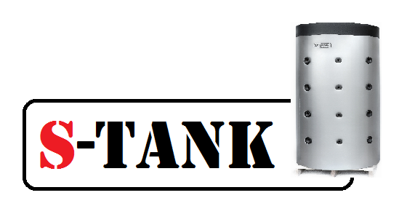

**Data sheet**

**for the SS-HP series tank**

**300**

**500**

**750**

**1,000**

**1,200**

**1,500**

**2,000**

**liters**

**for heating and accumulation**

**of heated sanitary water**

Republic of Belarus, township Ivenets, 2021

**SS-HP series tank diagram**

Magnesium anode

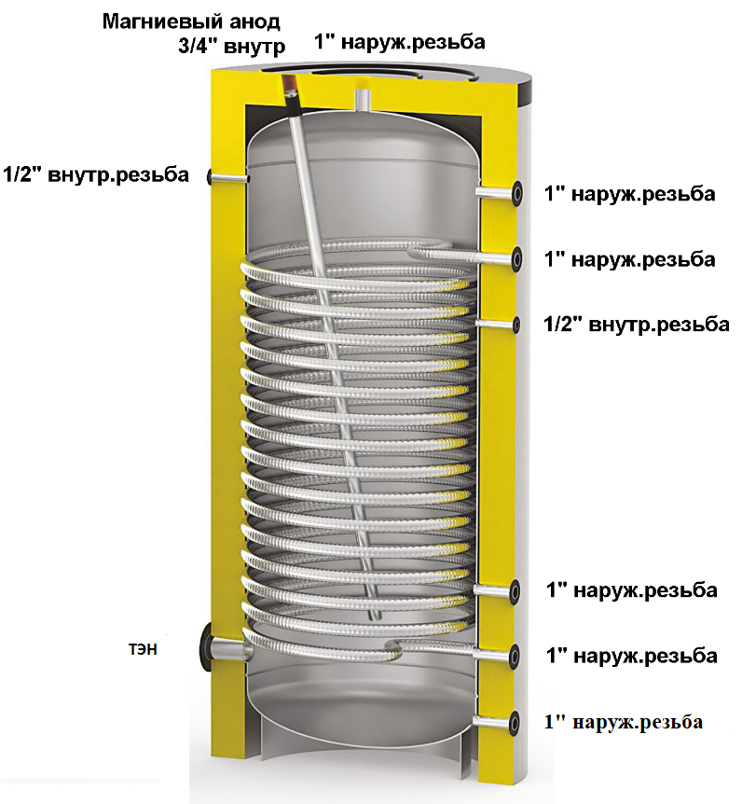

Outer thread

Outer thread

Outer thread

Outer thread

Outer thread

1/2"Inner thread

1/2"Inner thread

Outer thread

3/4"Inner thread

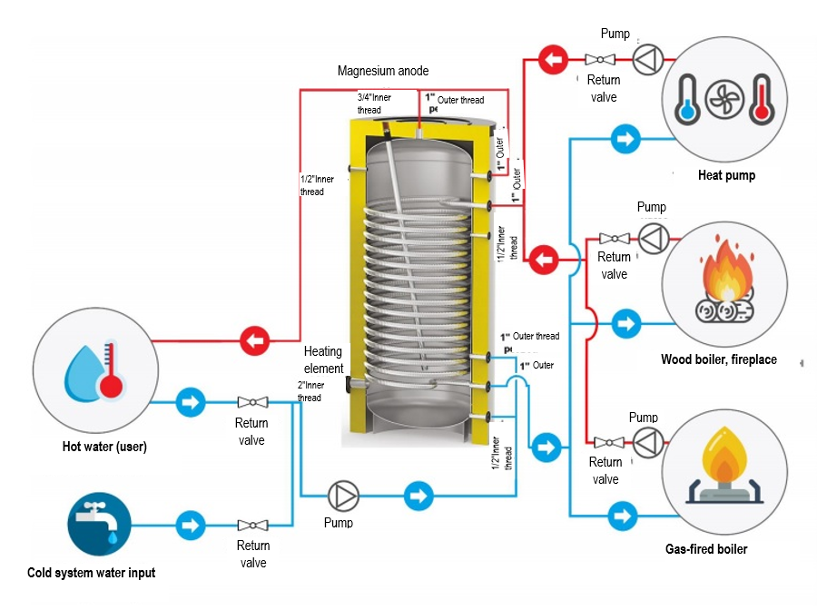

Field of application - accumulation and storage of hot sanitary water from a heat pump or high-capacity boilers.

Product material: - AISI 304 stainless steel

The SS-HP series tank has one very important feature for use in combination with heat pumps. A heat exchanger used in this tank is significantly dimensionally larger than that in a conventional indirect heating tank. What is the purpose of that? In fact, a heat pump, when discharging the heat, it produces through a condenser, has one very important indicator, such as the temperature difference at the condenser inlet and outlet and, as a rule, it ranges from 5 to 10 degrees Celsius in all modern heat pumps. If this indicator is not complied with, the heat pump will not meet the heating capacity and electricity consumption parameters declared by the manufacturer, and in addition, the heat pump may malfunction under high pressure. Therefore, the heat exchanger in our tank has a large inner diameter of 27 mm, thereby ensuring its low hydraulic resistance, and a large heat transfer surface area of 10 m2 (optionally, more than 10 m2 may be ordered). The heat exchanger for the heat pump should be selected based on the ratio of 1 kW capacity to 0.25 m2 of heat exchanger surface area. For example, the 10 kW heat pump is selected, hence, 10 x 0.25 = 2.5 m2 of heat exchanger surface area.

An opening with an inner diameter of 1 ½” is provided in tanks up to and including 500-liter capacity and 2" inner diameter in tanks having 750-liter capacity and more for mounting an electric heater which may be used to control Legionella.

The tank may be manufactured in the following modifications:

— fully made of stainless steel, with a heat exchanger + an opening for the heating element, or an inspection fitting flange with an opening for the heating element in the flange cover.

The tank insulation is made from 70 mm thick, 100% recyclable polyester (an environmentally friendly material) using the NOFIRE technology, this material is characterized by a high R-value and also a high B-s2d0 fire-resistance class in accordance with the European Standard EN 13501 requirements.

On the outside, the standard design tanks with a capacity of up to and including 2,000 l are protected by a plastic covering.

Options available:

Tank design modification according to a customer drawing (branch pipe mounting location, flanges, connection diameters, type and thickness of insulation) is calculated individually.

Be attentive choosing a DHW tank for a heat pump!

A tank-integrated heat exchanger surface area of at least 0.25 m2 should correspond to each 1 kW of the heat pump capacity. For example, a thermal pump with a capacity of 17 kW (at BO/W35) requires a tank with a heat exchanger surface area being 17 kW x 0.25 m2=4.25 m2.

**Specifications**

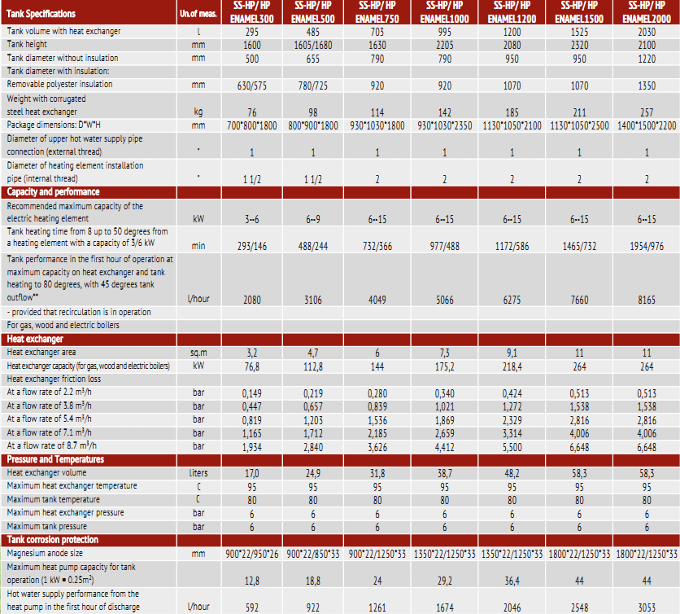

**A customized tank with operating pressure up to 10 bar may be manufactured.**

1. Arrangement, installation and operation.

2.1 Prior to the tank installation, please, read the Tank Certificate and Tank Installation and Operating Manual (read on [www.s-tank.ru](http://www.s-tank.ru))

2.2 Installation location needs to be chosen so that:

- in case of leakage from the tank the water is drained to a sewer trap and then freely discharged from the premises;

- it can be protected from shocks, industrial vibration, exposure to atmospheric precipitation (to be installed only in the premises). Any shock or mechanical impact may destroy the thermal insulation material and also cause tank leakage resulting in the tank failure!

When proceeding with the installation, it needs to be accounted that a free access should be provided to the tank for connecting, maintaining and disassembling it.

2.3 The tank should be installed by skilled specialists and persons having a certificate or a licence for performing works related to the heating system installation! The installation needs to be confirmed in the Warranty Certificate.

2.4. Wash the tank with water before putting it into operation!

- The tank should be earthed; for this purpose, one or more plates are welded to its support part at the tank bottom for securing them to a tray, and in their turn they may be also used for connecting the earth to the tank. The earthing bus resistance should be not more than 4 Ohm. An access to the earthing bus is to be provided by the Customer.

2.5. Acceptance of goods in terms of quality, completeness and quantity of units of goods in a package is to be made by the Buyer within two calendar days from receipt of the goods, but not later than 14 (fourteen) calendar days from the date of the goods handover.

2.6. The magnesium anode replacement period is not later than 6 months from the start of operation. The magnesium anode examination should be performed at least once every 6 months. The Correx anode functionality test should be performed at least once a year, and anode test results should be recordered in the Certificate (test date and test results).

2.7. It is not permitted to put the tank in operation without filling it with water.

2.8. It is not permitted to operate the tank without a properly functioning safety valve. The safety valve condition needs to be inspected every 14 days by turning a head (handle) to the left or to the right so that the water could flow from a side outlet to the outside. Then, set the handle in the initial position. If no fluid flows when turning the handle, then the valve is out of order. When turning the handle and returning it to the initial position a continuous water leakage is observed, then a valve plunger is soiled. Wash the valve several times by opening the outlet by turning the handle. To avoid the uncontrolled water outflow, a hose need to be mounted to drain water to the sewer.

2.9. It is prohibited to block fluid dripping from the safety valve - do not plug a safety valve port. If water continuously leaks from the valve, this means that the safety valve is out of order. The drain valve outlet should be oriented downward. It is recommended to mount a funnel under the valve for water drainage. A drainage hose may be mounted and put into the sewer to remove water which flows out when opening the safety valve. The hose should withstand a temperature of +95 degrees Celsius, has an inner diameter of 9 mm, maximum length of 1.2 m and a plane for water flow with an inclination downward (min 3%) and needs to be mounted in the premises in which the temperature does not drop below 0 degrees Celsius. The hose should be protected from mechanical damage and its outlet should be seen (to monitor the valve operation).

2.10. The tank should not be installed in close proximity o open fire or contact with the boiler insulation; when mounting a heating system with the tank, an installing organization should ensure compliance with fire safety regulations during the tank operation!

2.11. All works related to maintenance and installation should be performed in compliance with effective occupational safety rules.

3. Tank selection

3.1 The tank is to be selected individually depending on the heating system parameters or according to the project documentation.

3.2 The manufacturer reserves the right to make technical changes according to design documentation.

4. Warranty

4.1 The manufacturer guarantees conformity of the S-TANK SS HP series tanks to safety requirements, provided that the user observes transportation, storage, installation and operation rules. Warranty period - 2 years These warranty obligations will enter into effect upon registration of the product with the manufacturer within two months from the date of purchase.

The product is to be registered by mailing the required information to the manufacturer's address

[s-tank.garan@mail.ru](mailto:s-tank.garan@mail.ru), the list of required documents is provided in the Installation and Operating Manual<http://s-tank.by/wp-content/uploads/Instrukcziya-po-montazhu-i-ekspluataczii-bakov-S-TANK-2.pdf>in case the product is not registered, the warranty period is 1 (one) year from the date of sale.

4.2 Warranty implementation procedure. If warranty claims are grounded, the S-TANK WATER HEATERS service division takes a decision regarding the methods of eliminating identified faults - either by repairing or replacing a failed device. The warranty period specified in the Warranty Certificate remains unchanged in this case. In case of replacement of the failed device with a new one, the warranty period is not extended and the replacement is recorded in the Warranty Certificate.

4.3 The warranty does not cover the defects occurred due to the fault of the user as a result of violation of the Installation and Operating Manual, requirements of the Certificate and also in case of mechanical damage.

4.4. As regards malfunctions detected during the warranty period, please, contact the manufacturer/importer. A free-of-charge repair of malfunctions occured to the fault of the manufacturer should be performed within the period specified in the effective legislation from the date of certifying the failure as a warrantable failure by the manufacturer/importer.

IMPORTANT - It is not permitted to dismantle the tank upon occurrence of the warranty case until you get the manufacturer's permission.

4.5. To submit the notification of defects to the service division of the Importer/Seller, the following needs to be specified: invoice number and factory number of the product (read the information label), date of procurement, malfunction description, correct installation site address and telephone contact number.

4.6. The condition for performing the tank warranty repair implies submission of the sales receipt, invoice and correctly and fully completed Warranty Certificate by the user, with the name of the seller and installing organization and without any corrections. The Warranty Certificate needs to be retained within the entire period of the equipment operation.

4.7. It is not permitted to operate the tank without a properly functioning safety valve. To comply with the warranty, the purchase of a respective safety valve and safety valve Warranty Certificate need to be confirmed.

4.8. Installation and commissioning of the tank, being the warranty item, should be perfomed by skilled specialists subject to the rules established by the legislation and also according to Installation and Operating Manual (read on [www.s-tank.ru](http://www.s-tank.ru))

4.9. Protect to tank from direct solar radiation exposure.

4.10. The tank should be installed in zones not subjected to weather effects (rain, snow, etc.)

4.11. Plastic pipes not designed to operate at a temperature of 100 degrees Celsius and at a pressure 1.0 MPa should not be used for the tank connection.

4.12. The tank should be installed so that a free access is provided to it for maintenance.

4.13. The manufacturer is not liable for possible inconveniences or expenses related to the structural changes of a building/premises needed to meet the conditions of the tank installation location (for example, narrow doors or corridors) - the request for compensation the expenses will be declined by the manufacturer. If there is a need to install a water heater in a specific place (for example, in the attic or in a room with a floor sensitive to water impact, warehouses, etc.), the room should be protected against possible water ingress and the issue of mounting devices for collecting and draining this water to avoid damage shoud be considered.

4.14. All mechanical defects of teh tank lead to the loss of warranty.

4.15. The following will not be considered by the warranty if:

- the heating system with the tank was filled not with the distilled water solution or specially prepared solution for filling the heating system, with the respective quality certificate being provided (for tanks configured for heating systems);

- the heating system was not earthed (this is necessary to prevent the influence of parasite (earth) currents on metal and as a result corrosion occurrence and acceleration);

- the tank was used in heating systems with air available in the network (for tanks configured for heating systems);

- the tank was not earthed (this is necessary to prevent the influence of parasite (earth) currents on metal and as a result corrosion occurrence and acceleration);

- the tank was used in the heating and DHW system not equipped with a respective safety assembly for excessive pressure release;

- the tank was used in aggressive media;

- low-quality installation;

- the expansion tank of a required capacity (10% of the system capacity) is not available for the closed heating and DHW system;

- The quality of sanitary hot water in the tank and heat exchanger should comply with the following DHW standards:

|  |  |  |
| --- | --- | --- |
| **Conductivity mc/cm *)** | **>450** | **-** |
| **pH** | **<6** | **0** |
|  | **6-8+** | **+** |
|  | **>8** | **-** |
| **Chlorides (mg/l)** | **>50** | **-** |
| **Sulfur compounds(mg/l)** | **<50+** | **+** |
|  | **50-200 0** | **0** |
|  | **>200** | **-** |
| **Nitrogen compounds (mg/l)** | **<100** | **+** |
| **Carbon dioxide (mg/l)** | **<5 +** | **+** |
|  | **5-20 0** | **0** |
|  | **>20** | **-** |
| **Oxygen (mg/l)** | **<1 +** | **+** |
|  | **1-8 0** | **0** |
|  | **>8** | **-** |
| **Amone (mg/l)** | **<2 +** | **+** |
|  | **2-20 0** | **0** |
|  | **>20** | **-** |
| **Ferrum and manganese (mg/l)** | **>0.2** | **0** |
| **Sulfur compounds(mg/l)** | **<5** | **-** |
| **Chlorine (mg/l)** | **<0.5** | **+** |

*) at 20 degrees Celsius

+ = resistant material

0 - destruction may occur, if several substances reach the value of ‘’ 0 ‘’

- - not recommended to use

Important: the condition of a magnesium anode (magnesium anodes - 2 pcs - for models with enhanced degree of protection) should be inspected at leasts once every 6 months! The Correx anode functionality test should be performed at least once a year, and anode test results should be recordered in the Certificate (test date and test results).

- damage was caused by improper transportation;

- damage was caused intentionally or damage occurred due to negligence;

- mechanical damage or damage are caused by weather effects (for example, frost) or actions arising from exceeding the allowable operational pressure specified in the Certificate

- malfunctions caused by the use of fittings being not in compliance with effective standards;

- accidents are caused by installation or operation of malfunctioning or damaged safety valves

- damage resulted from improper use;

- damage resulted from non-observance of rules contained in the Certificate and in the Tank Installation and Operating Manual (read on [www.s-tank.ru](http://www.s-tank.ru))

- damage occurred as a result of fire, flood, lightning strike, voltage surge in the electrical network or other cases;

- accidents occurred as a result of using non-original spare parts such as TEH assembly, magnesium anode, titanium anode, thermostat, thermometer, gaskets, etc.;

- electrochemical corrosion occurred;

- damage due to failure to replace the magnesium anode within the terms specified in the Certificate;

- cases related to the natural formation of scaling;

- damage resulting from irregular cleaning of the DHW tank from scale and sediment;

4.19. The tank repair techniques are to be defined by the manufacturer.

4.20. A free-of-charge repair does not include as follows: tank adjustment, magnesium anode replacement, seal replacement or other parts naturally wearable in the process of operation.

4.21. These are the only warranty conditions of the manufacturer. No other warranties are accepted, unless manufacturer's instructions in writing are provided.

4.22. Civil Code regulations are applied to the issues not adressed by these conditions.

5. Storage conditions:

Store the product prior to commissioning in a heated room at a temperature not below 20°С and relative humidity not more than 65%.

**Standard product configuration:**

1. Tank - 1 ps
2. Unremovable thermal insulation up to 500 l, removable - 750 l and more - 1 pc
3. Upper decorative cover with a seal (plastic up to 1,000 l, fabric - 1,200 l and more) - 1 pc
4. Thermometer - 1 ps
5. Product Certificate - 1 ps
6. Magnesium anode - 1 ps
7. Titanium anode with a power supply unit (option upon request) - 1 ps, in case the titanium anode is mounted, no need to mount the magnesium anode.

Quality control for defects was performed by Gubsky M.N., specialist of the Technical Control Department (TCD)

Sale date ________________________________________________________

Signature of Seller ________________________________________________________

Name and address of the trading organization _________________________________________________________________________________________________________________________________________________

Seal

Name and address of the mounting organization _________________________________________________________________________________________________________________________________________________Seal

Seal

**Magnesium anode replacement Table**

|  |  |  |  |  |  |
| --- | --- | --- | --- | --- | --- |
| Replacement date | No. and date of sale receipt, invoice | Anode model | Organization replacing the anode | Full name | Signature |
|  |  |  |  |  |  |

Manufacturer:

S-TANK WATER HEATERS LTD, RB, Minsk Region

Build. 72B, 17-ogo Sentyabrya Str., township Ivenets, Volozhinsky District

Tel-fax 8(01772) 6 77 11; Tel. +375296325040, +375296131414

Technical support: [alfa-vim@mail.ru](mailto:alfa-vim@mail.ru)